ST. XAVIER’S COLLEGE
MAITIGHAR, KATHMANDU, NEPAL
Phone: 01-5321365, 01-5344636
Email: ktm@sxc.edu.np



LAB/WRITTEN ASSIGNMENT NUMBER:5

“Web Technology I- ”

Submitted By | Submitted To | Signature
Name: Aaditya Karn  Roll No: 703  Class: 11  Section: G | Mr. Jaya Sundar Shilpakar  Department of Computer Science,  NEB (Plus Two)  St. Xavier’s College

Submission Date:2nd September, 2026

Table of Contents
1 Web Development
2 Some Terms
3 HTML
4 Some Basic Tags of HTML
5 Basic HTML Webpage Structure
6 Lab Activity
6.1 Table of Contents.html
6.2 Chap1.html
6.3 Chap2.html
6.4 Chap3.html
6.5 Chap4.html
6.6 Chap5.html
6.7 Chap6.html
6.8 Chap7.html
6.9 Chap8.html
7 Reflection
8 Conclusion

Figure 6-1: Tabs and Groups of MS Word 2
Figure 8.0-1: Lifecycle of a Butterfly 2
Figure 9.9-1: Ecological Foodchain Pyramid 2
Figure 10-1: Professional Curriculum Vitae 2
Figure 11-1: Corporate Visiting Card 2
Figure 12-1: Institutional ID Card 2
Figure 13-1: Final Mail Merge Output Preview 2

WORD PROCESSOR

A word processor is application software used to create, edit, format, save, and print text documents. It enables users to prepare letters, reports, resumes, books, and other documents quickly and efficiently. A word processor provides features such as text formatting, spell and grammar checking, inserting tables, pictures, charts, and page layout tools. It also allows users to save documents for future editing and share them in different file formats. Popular word processors include Microsoft Word, Google Docs, LibreOffice Writer, WPS Writer, and Apple Pages. Today, word processors are widely used in schools, offices, businesses, and homes because they make document creation easy, accurate, and professional.

The concept of word processing originated in the late 1960s and became popular during the 1970s, evolving from electronic typewriters into computer-based software. Since then, word processors have advanced significantly, with modern applications such as Microsoft Word and Google Docs offering powerful editing, formatting, and collaboration features.

MICROSOFT OFFICE PACKAGE

Microsoft Office is a collection of application software developed by Microsoft. It is used to create documents, spreadsheets, presentations, databases, and emails. The package includes programs such as Microsoft Word, Excel, PowerPoint, Access, and Outlook. Microsoft Word is used for word processing, while Excel is used for calculations and data analysis. PowerPoint helps in creating attractive presentations. MS Office improves productivity and is widely used in schools, offices, and businesses. It is one of the most popular office software packages in the world.

FEATURES OF WORD PROCESSOR
- Advanced Spell and Grammar Checking -Modern word processors use intelligent language tools to detect spelling, grammar, punctuation, and style errors. They also suggest corrections to improve the quality of writing.
- Real-time Collaboration-It enables multiple users to work on the same document simultaneously. Users can view edits, add comments, and track changes in real time, making teamwork easier and more efficient.
- Security and Password Protection-Word processors allow users to protect documents with passwords and encryption. This prevents unauthorized access and helps keep confidential information secure.
- Templates and Document Design-This feature provides ready-made templates for letters, reports, resumes, brochures, and other documents. Users can create professional-looking documents quickly with minimal effort.
- Document Assembly is a feature that automatically creates documents by combining predefined text, templates, and data. It organizes different sections of a document according to the user's requirements. This feature reduces manual work, saves time, and ensures consistency in document formatting. It is commonly used for generating reports, contracts, invoices, and business letters.
- Version Control and Document History is a feature that keeps track of all changes made to a document over time. It allows users to view, compare, and restore previous versions whenever needed. This feature helps prevent data loss and makes it easy to recover earlier edits. It is especially useful when multiple users are working on the same document.

APPLICATIONS OF WORD PROCESSING
- Creating Documents – Used to create letters, reports, notices, resumes, and other text documents.
- Editing Documents – Allows users to add, delete, copy, cut, paste, and modify text easily.
- Formatting Documents – Changes the appearance of text and pages using fonts, styles, colors, margins, and spacing.
- Storing Documents – Saves documents electronically for future use and easy retrieval.
- Printing Documents – Produces high-quality printed copies of documents.

- Sharing Documents – Enables documents to be shared electronically through email or cloud services and in various file formats.
- Managing Documents – Helps organize, search, update, and maintain documents Efficiently.

APPLICATION AREAS OF WORD PROCESSOR

- Education – Used by students and teachers to prepare assignments, question papers, notes, and project reports.
- Business – Helps create letters, invoices, reports, contracts, meeting agendas, and business proposals.
- Government Offices – Used for preparing official documents, notices, circulars, forms, and records.
- Publishing – Assists in writing and formatting books, magazines, newspapers, newsletters, and journals.
- Personal Use – Used to write resumes, letters, invitations, greeting cards, and personal documents.

Types Of Word Processors

1. Text-Based Word Processor
A text-based word processor is a type of word processor that works mainly with text and is operated using keyboard commands. It has a simple interface with limited formatting features and usually does not support graphics or images. Early word processors such as WordStar and WordPerfect (DOS version) are examples of text-based word processors.
2. Graphical Word Processor
A graphical word processor uses a graphical user interface (GUI), allowing users to create and edit documents using menus, icons, and toolbars. It supports advanced formatting, images, tables, charts, and other multimedia elements. Microsoft Word, LibreOffice Writer, and Apple Pages are examples of graphical word processors.
3. Web-Based Word Processor
A web-based word processor is an online application that runs in a web browser without requiring installation on a computer. It allows users to create, edit, save, and share documents over the internet and supports real-time collaboration. Google Docs, Microsoft Word Online, and Zoho Writer are examples of web-based word processors.

- Microsoft Word
- WPS Office,
- iWork Pages,
- LibreOffice Writer
- Scrivener,
- FocusWriter
- FreeOffice Text Maker
- Google Docs
- Notion
- Dropbox Pape

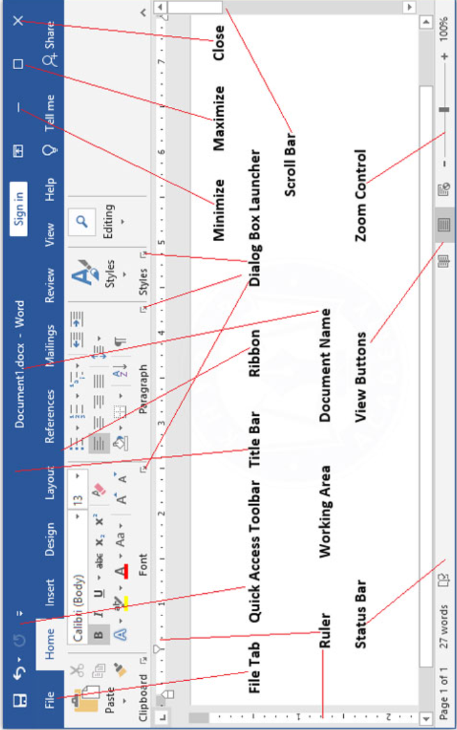
Figure 0-1: Tabs and Groups of MS Word

Architecture of Microsoft Word (Tabs & Groups)
Microsoft Word (MS Word) is a word processing application developed by Microsoft. It is used to create, edit, format, save, and print text documents. MS Word provides tools for inserting tables, pictures, charts, shapes, and other objects. It also includes features such as spell check, grammar check, templates, and mail merge. MS Word is widely used in schools, offices, businesses, and homes for preparing professional documents.

Tabs and Groups of MS-WORD
Tab | Groups | Options/Commands
File | Document Management | New, Open, Info, Save, Save As, Print, Share, Export, Close, Account, Options
Home | Clipboard | Paste, Cut, Copy, Format Painter
 | Font | Font, Font Size, Increase Font Size, Decrease Font Size, Change Case, Clear Formatting, Bold, Italic, Underline, Strikethrough, Subscript, Superscript, Text Effects, Text Highlight Color, Font Color
 | Paragraph | Bullets, Numbering, Multilevel List, Decrease Indent, Increase Indent, Sort, Show/Hide (¶), Align Left, Center, Align Right, Justify, Line & Paragraph Spacing, Shading, Borders
 | Styles | Quick Styles
 | Editing | Find, Replace, Select
Insert | Pages | Cover Page, Blank Page, Page Break
 | Tables | Table
 | Illustrations | Pictures, Online Pictures, Shapes, Icons, 3D Models, SmartArt, Chart, Screenshot
 | Links | Link (Hyperlink), Bookmark, Cross-reference
 | Comments | Comment
 | Header & Footer | Header, Footer, Page Number
 | Text | Text Box, Quick Parts, WordArt, Drop Cap, Signature Line, Date & Time, Object
 | Symbols | Equation, Symbol
Design | Themes | Themes
 | Document Formatting | Colors, Fonts, Paragraph Spacing, Effects
 | Page Background | Watermark, Page Color, Page Borders
Layout | Page Setup | Margins, Orientation, Size, Columns, Breaks, Line Numbers, Hyphenation
 | Paragraph | Left Indent, Right Indent, Spacing Before, Spacing After
 | Arrange | Position, Wrap Text, Bring Forward, Send Backward, Selection Pane, Align, Group, Rotate
References | Table of Contents | Table of Contents
 | Footnotes | Insert Footnote, Insert Endnote
 | Citations & Bibliography | Insert Citation, Manage Sources, Style, Bibliography
 | Captions | Insert Caption, Table of Figures, Cross-reference
 | Index | Mark Entry, Insert Index
 | Table of Authorities | Mark Citation, Insert Table of Authorities
Mailings | Create | Envelopes, Labels
 | Start Mail Merge | Start Mail Merge, Select Recipients, Edit Recipient List
 | Write & Insert Fields | Highlight Merge Fields, Address Block, Greeting Line, Insert Merge Field
 | Preview Results | Preview Results
 | Finish | Finish & Merge
Review | Proofing | Spelling & Grammar, Thesaurus, Word Count
 | Language | Translate, Language
 | Comments | New Comment, Delete, Previous, Next
 | Tracking | Track Changes, Display for Review
 | Changes | Accept, Reject, Previous Change, Next Change
 | Compare | Compare, Combine
 | Protect | Restrict Editing
View | Views | Read Mode, Print Layout, Web Layout
 | Show | Ruler, Gridlines, Navigation Pane
 | Zoom | Zoom, 100%, One Page, Multiple Pages, Page Width
 | Window | New Window, Arrange All, Split, View Side by Side, Switch Windows
 | Macros | Macros
Help | Help | Help, Training, Contact Support, Feedback

Table 7.7.1: Architectural Mapping of MS Word Ribbon Tabs and Functional Groups

File Tab
The File tab is used to create, save, print, share, and manage documents.
Options and Functions
- New – Creates a new blank document or a document from a template.
- Open – Opens an existing document.
- Info – Displays document properties and allows protection, inspection, and version management.
- Save – Saves the current document.
- Save As – Saves the document with a different name, location, or file format.
- Print – Prints the document and changes print settings.
- Share – Shares the document through email or cloud services.
- Export – Converts the document into PDF/XPS or another file type.
- Close – Closes the current document.
- Account – Manages Microsoft account, Office theme, and updates.
- Options – Opens Word settings to customize the application.

Home Tab
The Home tab contains the most frequently used commands for editing and formatting text.
Clipboard Group
- Paste – Inserts copied or cut content.
- Cut – Removes selected content and places it on the clipboard.
- Copy – Copies selected content to the clipboard.
- Format Painter – Copies formatting from one place and applies it elsewhere.
Font Group
- Font – Changes the font style.
- Font Size – Changes the size of text.
- Increase Font Size – Makes text larger.
- Decrease Font Size – Makes text smaller.
- Change Case – Converts text to uppercase, lowercase, sentence case, etc.
- Clear Formatting – Removes all formatting from selected text.
- Bold – Makes text bold.
- Italic – Makes text italic.
- Underline – Underlines the text.
- Strikethrough – Draws a line through the selected text.
- Subscript – Places text slightly below the baseline.
- Superscript – Places text slightly above the baseline.
- Text Effects – Adds shadow, glow, reflection, and other effects.
- Text Highlight Color – Highlights selected text.
- Font Color – Changes the color of the text.
Paragraph Group
- Bullets – Creates a bulleted list.
- Numbering – Creates a numbered list.
- Multilevel List – Creates outline-style lists.
- Decrease Indent – Moves the paragraph closer to the left margin.
- Increase Indent – Moves the paragraph farther from the left margin.
- Sort – Sorts selected text alphabetically or numerically.
- Show/Hide (¶) – Displays formatting marks.
- Align Left – Aligns text to the left.
- Center – Centers text.
- Align Right – Aligns text to the right.
- Justify – Aligns text evenly on both margins.
- Line and Paragraph Spacing – Changes spacing between lines and paragraphs.
- Shading – Adds background color to paragraphs.
- Borders – Adds or removes borders.
Styles Group
- Quick Styles – Applies predefined formatting styles to text.
Editing Group
- Find – Searches for specific words or phrases.
- Replace – Finds and replaces text.
- Select – Selects text or objects.

Insert Tab
The Insert tab is used to insert objects into the document.
Pages Group
- Cover Page – Inserts a ready-made cover page.
- Blank Page – Inserts a new blank page.
- Page Break – Starts content on a new page.
Tables Group
- Table – Inserts a table.
Illustrations Group
- Pictures – Inserts images from the computer.
- Online Pictures – Inserts pictures from the internet.
- Shapes – Inserts shapes.
- Icons – Inserts icons.
- 3D Models – Inserts 3D objects.
- SmartArt – Inserts diagrams.
- Chart – Inserts charts.
- Screenshot – Inserts screenshots.
Links Group
- Link (Hyperlink) – Creates a hyperlink.
- Bookmark – Marks a location in the document.
- Cross-reference – Refers to another part of the document.
Comments Group
- Comment – Adds comments.
Header & Footer Group
- Header – Inserts a header.
- Footer – Inserts a footer.
- Page Number – Inserts page numbers.
Text Group
- Text Box – Inserts a text box.
- Quick Parts – Inserts reusable content.
- WordArt – Inserts decorative text.
- Drop Cap – Creates a large first letter.
- Signature Line – Inserts a signature line.
- Date & Time – Inserts the current date and time.
- Object – Embeds another file or object.
Symbols Group
- Equation – Inserts mathematical equations.
- Symbol – Inserts special characters.

Design Tab
The Design tab changes the overall appearance of the document.
Themes Group
- Themes – Applies a complete document theme.
Document Formatting Group
- Colors – Changes theme colors.
- Fonts – Changes theme fonts.
- Paragraph Spacing – Changes spacing.
- Effects – Applies visual effects.
Page Background Group
- Watermark – Adds background text or image.
- Page Color – Changes page background color.
- Page Borders – Adds borders around the page.

Layout Tab
Page Setup Group
- Margins – Sets page margins.
- Orientation – Changes page orientation.
- Size – Changes paper size.
- Columns – Divides text into columns.
- Breaks – Inserts page or section breaks.
- Line Numbers – Adds line numbers.
- Hyphenation – Automatically hyphenates words.
Paragraph Group
- Indent Left/Right – Changes paragraph indentation.
- Spacing Before/After – Changes spacing around paragraphs.
Arrange Group
- Position – Positions objects.
- Wrap Text – Wraps text around objects.
- Bring Forward – Moves object in front.
- Send Backward – Moves object behind.
- Selection Pane – Displays object list.
- Align – Aligns objects.
- Group – Groups objects together.
- Rotate – Rotates objects.

References Tab
Table of Contents Group
- Table of Contents – Creates a table of contents.
Footnotes Group
- Insert Footnote – Adds a footnote.
- Insert Endnote – Adds an endnote.
Citations & Bibliography Group
- Insert Citation – Adds citations.
- Manage Sources – Manages source list.
- Style – Selects citation style.
- Bibliography – Creates a bibliography.
Captions Group
- Insert Caption – Adds captions to figures or tables.
- Table of Figures – Creates a table of figures.
- Cross-reference – Links to figures or tables.
Index Group
- Mark Entry – Marks index entries.
- Insert Index – Creates an index.
Table of Authorities Group
- Mark Citation – Marks legal citations.
- Insert Table of Authorities – Creates a table of legal references.

Mailings Tab
Create Group
- Envelopes – Creates envelopes.
- Labels – Creates labels.
Start Mail Merge Group
- Start Mail Merge – Begins mail merge.
- Select Recipients – Chooses recipient list.
- Edit Recipient List – Modifies recipient list.
Write & Insert Fields Group
- Highlight Merge Fields – Highlights merge fields.
- Address Block – Inserts address block.
- Greeting Line – Inserts greeting.
- Insert Merge Field – Inserts custom merge fields.
Preview Results Group
- Preview Results – Shows merged documents.
Finish Group
- Finish & Merge – Completes mail merge.

Review Tab
Proofing Group
- Spelling & Grammar – Checks spelling and grammar.
- Thesaurus – Finds synonyms.
- Word Count – Counts words.
Language Group
- Translate – Translates text.
- Language – Sets proofing language.
Comments Group
- New Comment – Adds comments.
- Delete – Deletes comments.
- Previous/Next – Moves between comments.
Tracking Group
- Track Changes – Records edits.
- Display for Review – Chooses review mode.
Changes Group
- Accept – Accepts changes.
- Reject – Rejects changes.
- Previous/Next – Navigates changes.
Compare Group
- Compare – Compares documents.
- Combine – Combines revisions.
Protect Group
- Restrict Editing – Protects the document.

View Tab
Views Group
- Read Mode – Displays document for reading.
- Print Layout – Shows print layout.
- Web Layout – Shows web page layout.
Show Group
- Ruler – Displays ruler.
- Gridlines – Displays gridlines.
- Navigation Pane – Opens navigation pane.
Zoom Group
- Zoom – Changes zoom level.
- 100% – Returns to actual size.
- One Page – Displays one page.
- Multiple Pages – Displays multiple pages.
- Page Width – Fits page width.
Window Group
- New Window – Opens another window.
- Arrange All – Arranges windows.
- Split – Splits the document window.
- View Side by Side – Compares two documents.
- Switch Windows – Switches between open documents.
Macros Group
- Macros – Creates, edits, and runs macros.

Help Tab
Help Group
- Help – Opens Word help.
- Training – Opens learning resources.
- Contact Support – Connects to Microsoft support.
- Feedback – Sends suggestions or reports problems to Microsoft.|

LAB TASKS

LAB TASK-1

Lifecycle of a Butterfly (Smart Art)

Defn:- A graphical representation of lifecycle of a butterfly created using the SmartArt feature of Microsoft Word.

Steps
In Microsoft Word:
- Go to insert tab.
- Click SmartArt option in the illustrations tab.
- Select cycle in the SmartArt menu.
- Enter the image of the stages of the lifestyle from the insert tab, pictures.
- Write the labels.
- Save the document.

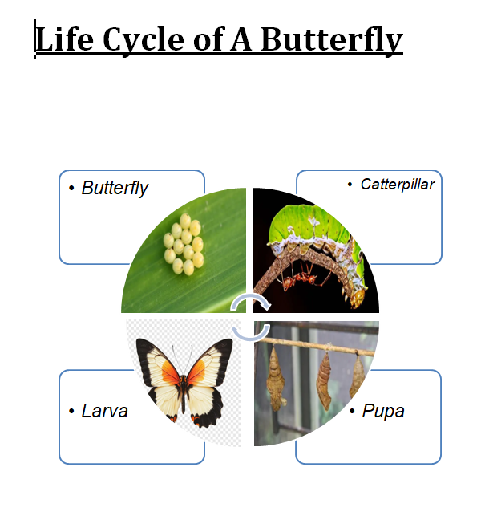
Figure 8.0-1: Lifecycle of a Butterfly

LAB TASK-2: Ecological Food chain Pyramid (Shapes & Formatting)

Defn: It is a graphical representation of the different Stages in ecological food chain pyramid, created in MS-word using shapes and formatted.

Steps

In a blank document of MS-Word
Type the title
Triangle shape and other required shapes were added from the illustration group of the insert tab.
Text boxes should be added and the labels should be mentioned.
Apply colors by editing the shape and insert pictures from the insert tab, pictures group.

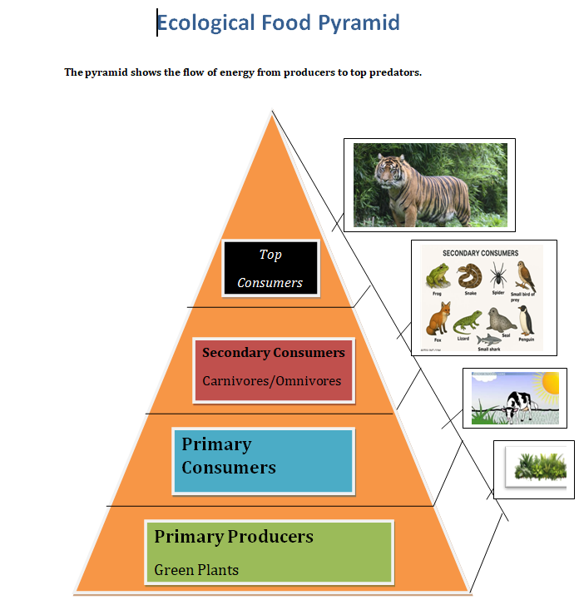
Figure 9.9-1: Ecological Foodchain Pyramid

LAB TASK-3: Professional Curriculum Vitae

Defn: A professional curriculum vitae prepared by using options like Shapes, pictures, home tab of the MS-Word.

Steps

In a new blank document of MS Word:
- Using the shapes option present in the insert tab design the layout of the page.
- Insert text boxes in the necessary places, from the text group of the insert tab.
- Add the essential details and format them from the home tab, text, font size, font color, etc.
- Insert the passport size photo of the person using the picture option in the insert tab.

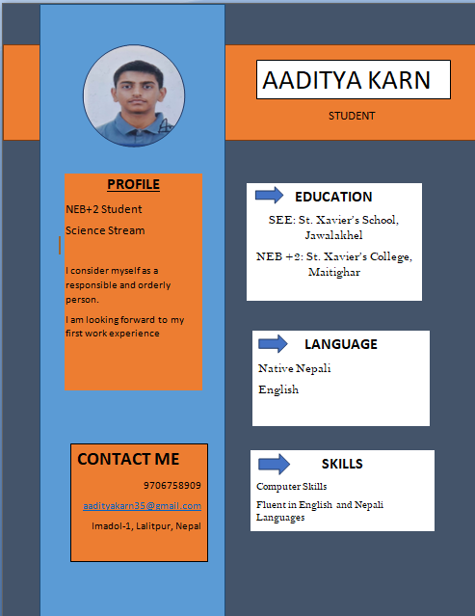
Figure 10-1: Professional Curriculum Vitae

LAB TASK-4: CORPORATE VISITING CARD

Defn: A professional visiting card designed in MS-word using shapes, formatting.

Steps
In a new blank document of MS-Word:
- Insert a rectangular box using shapes for the outline of the card.
- From the pictures open insert the logo of the company.
- By adding text boxes type the essential details.
- Format the text by using various options present in the Font group of home tab.
- Add more shapes to make better design.

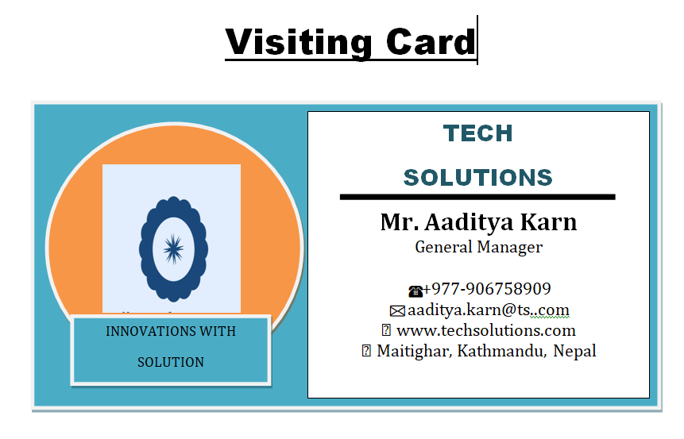

Figure 11-1: Corporate Visiting Card

LAB TASK-5: Institutional Identity Card Design

Defn: An official identification cared of an instituition created. in MS-Word using its various features.

Steps:
- In a new blank document of MS word:
- Using shapes draw the outline of the ID card.
- From picture option in the insert tab insert the logo and picture of the Institution and picture of the person.
- Using text boxes add the details of the person.

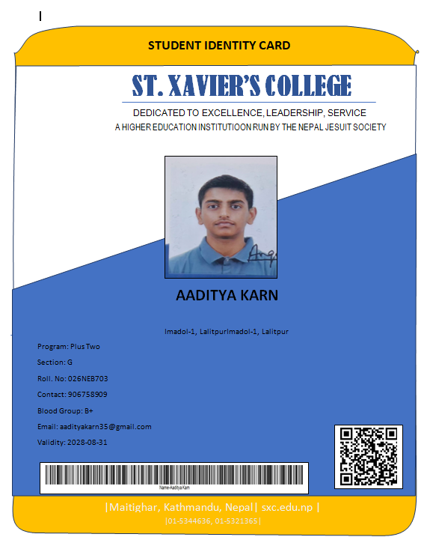
Figure 12-1: Institutional ID Card

LAB TASK-6:Mail Merge Database operations.

Defn. Mail merge is a feature in MS-Word that creates. multiple personalized documents by combining the layout of main document with recipient list.

Steps:

In a new blank document of MS-Word
- Create the design of ID card as in Lab task-5.
- Start mail merge from the mailings tabs.
- Create a recipient list
- Tab: Mailings Group: Start mail merge Option: Select recipients→ Type a new list.
- Add the fields and required details in the recipient list.
- Insert the merge fields into the text boxes of the ID card using the insert merge field option. Eg: <<Name>>
- Preview the ID cards using preview results
- option.
- Generate the ID cards by selecting the Finish & Merge option.

Office_Address_List
Name | Address | Program | Section | Roll | Contact | Blood group | Email | Validity
AADITYA KARN | Imadol-1, Lalitpur | Plus Two | G | 026NEB703 | 906758909 | B+ | aadityakarn35@gmail.com | 2028-08-31
AADHESH KHATIWADA | Sanothimi, Bhaktapur | Plus Two | G | 026NEB701 | 903052789 | B+ | aadhesh01@gmail.com | 2028-08-31
AADITYA CHAULAGAIN | Koteshwor,Kathmandu | Plus Two | G | 026NEB702 | 984623920 | A+ | aadityachaulagain@gmail.com | 2028-08-31
AAGAMAN DHAKAL | Budhanilkantha | Plus Two | G | 026NEB704 | 985467890 | O+ | imaagaman@gmail.com | 2028-08-31
AALOK ARYAL | Balaju | Plus Two | G | 026NEB704 | 985438890 | B- | aalokdj@gmail.com | 2028-08-31

Table 13.1: Recipient Database Source Configuration Sheet

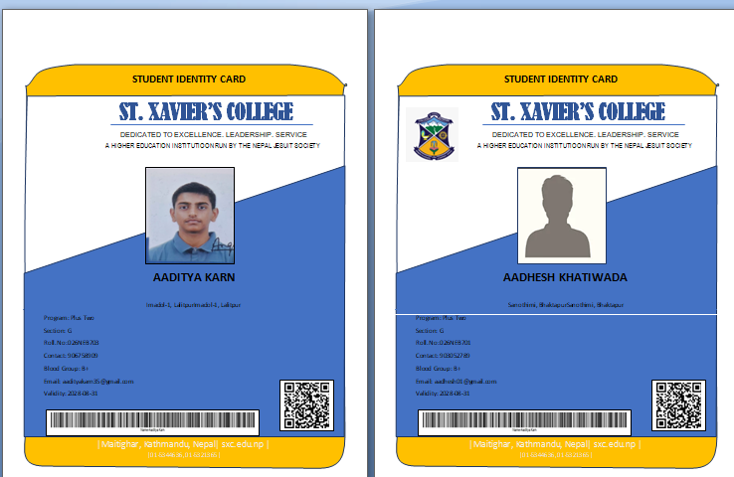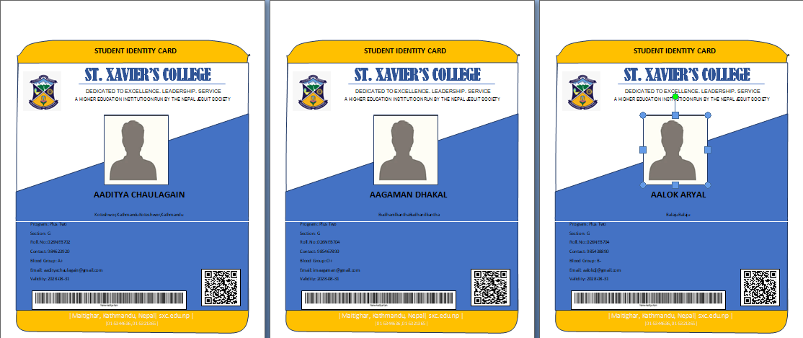

Figure 13-1: Final Mail Merge Output Preview

LAB TASK-7: Essential Keyboard Shortcuts (Table).

STEPS:

In a new blank document of MS-Word:
- Using the table option in the insert tab create a table with required number of rows and columns.
- Insert the short-cut keys and their function into the rows and columns.
- Format the text using the font group in home tab.

SHORTCUT KEYS | FUNCTION
Ctrl + X | Cut
Ctrl + C | Copy
Ctrl + v | Paste
Ctrl + z | undo
Ctrl + A | Select all
Ctrl + F | Find
Ctrl + B | Bold
Ctrl + I | Italicize Text
Ctrl + Backspace | Delete Previous Word
Ctrl + Left Arrow | Move cursor to start of line
Ctrl + Right Arrow | Move cursor to end of line
Ctrl + l | Left Alignment
Ctrl + J | Justify
Ctrl + 1 | Single Spacing
Ctrl + 5 | 1.5 Line Spacing
Ctrl + Left/Right Arrow | Jump Word-by-Word
Ctrl + Up/Down Arrow | Jump Paragraph-by-Paragraph
Ctrl + Home, Ctrl + End | Go to Start/End of Document
Ctrl + Shift + Left/Right Arrow | Select Word-by-Word

Table 14.1: Important Shortcuts

REFLECTION

Reflection Lab-1
In the first lab, I learned about the basic features of MS-Word. I also navigated through various tabs, groups and options. To also completed my first lab task of creating a Lifecycle of a Butterfly' which helped me understand about the smart art feature of the word Processor.

Reflection: Lah-2..
During the second lab, I learned to create professional documents dike a curriculums vitae and a visiting cared. These tasks especially included use of feature like Shapes, text box and a little of text formatting as-well.

Reflection: Lab-3
In the third lab, I discovered and learned about a relatively advanced feature of MS-Word, i.e. Mail merge. I learned the process of creating recipient list and creating multiple Personalized documents & easily by using the feature. This showed how word processor can make life efficient.

Conclusion of Report

In conclusion, MS word is a word processer full of useful features that can be used for various operation Through this lab report I also learned theoretical Concept about MS-Word. The activities done taught me to use simple and advanced features of MS-Word that can make our life easier and creating documents mare efficient and faster.

This activity improved my skills and helped me learn about near advanced and useful features of MS-Word.

